Romanesque Architecture; Aachen Cathedral
Name
Institution
Date

It is incredible how a building that has stood the test of ages still position to date, their fantastic form of architectural work that defines a creative sense of fashion, simplicity at its best and a classical way of determining power. Romanesque architecture became the first pan-European architectural style since Imperial Roman Architecture that was behind the construction of elegant townhouses, grand palaces, commercial premises, civic buildings, castles, city walls, bridges and even massive cathedrals. The Romanesque architecture was a style of medieval Europe characterized by semi-circular arches, structures of enormous quality, thick walls, round arches, sturdy pillars, barrel vaults, massive towers and decorative arcading. Each building bears defined forms, frequently of very regular, symmetrical plan and the overall appearance is one of simplicity when compared with the gothic buildings that were to follow (Hans Jürgen, 2011).
The name Roman (esque) we give to this architecture, which should be universal as it is the same everywhere with slight local differences, also has the merit of indicating its origin and is not new since it is used already to describe the language of the same period. The use of the term is now only restricted to the definition of the 10th to 12th century. Ideally, castles and churches were built the most with the latter holding more numbers of surviving Romanesque buildings that still stand to be frequently used. The churches were mainly founded by rulers as seats of temporal and religious power or places of innovation and burial. These churches have and will contribute to being cornerstones of architecture and history. They entail a majority of the human civilization history and depict the picture of the old days and the legendaries of old. These include the Abbey-Saint Dennis, Speyer Cathedral, and Aachen Cathedral-that will be our point of discussion.
Aachen Cathedral is an Achen Roman Catholic church, western Germany, and the seat of the Roman Catholic Diocese of Aachen and on a 0.2 hectare of land. Known as the ‘Royal church of St. Mary' during the middle age. Its architectural style is unique with a composite of Carolingian, Ottonian, and Gothic. It is one of the oldest Catholic churches that were constructed in 805 following the orders of emperor Charlemagne(Karl der Grosse in German)-the first Holy Roman emperor- to build the Palatine Chapel around 796 and happened to have been buried in the church after his death in 814. The construction is credited to one Odo of Metz with the exact day of completion unclear but it after its completion it was crowned the "masterpiece of Carolingian architecture". For the better part of 595 years dating from 936 to 1531, the Palatine Chapel-a key feature of the Cathedral- was the church of coronation for thirty-one German kings and twelve queens. This church has been the mother church of the Diocese of Aachen since 1802 (ISBN).
The church suffered damage largely in a Viking raid in 881 and later restored in 983. This was not just enough pain to the building as later on in World War 2 where Germany had been leading the upfront war against the Allied forces, the Aachen including the cathedral was heavily damaged by bombing attacks and artillery fire, but the cathedral's basic structure survived. However, the glazing of the 14th-century choir hall, the Neo-Gothic altar, a large part of the cloister, and the Holiness chapel were irretrievably destroyed. This was followed by reconstruction and restoration of the cathedral of more than 30 years at an estimated cost of over 40 million euros. The Aachen cathedral was however recognized as one of the first 12 items to be listed in the UNESCO list of world heritage sites in 1978 (ISBN)
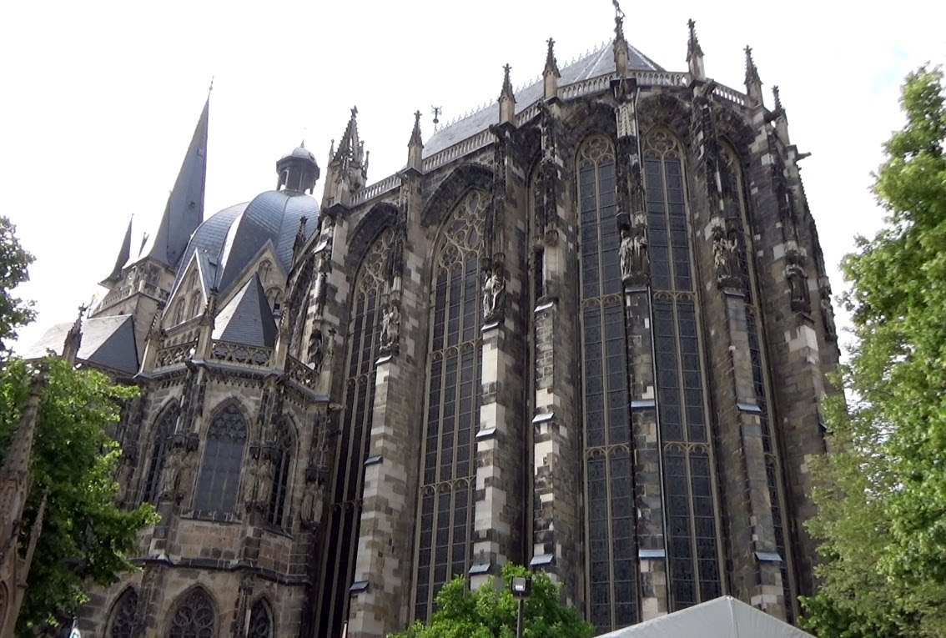
Structure:
According to McClendon, 1996 he says that the cathedral uses two distinct architectural styles, with small portions of a third. First, the core of the cathedral is the Carolingian-Romanesque Palatine Chapel, which was modeled after SanVitale at Ravenna and is notably small in comparison to the later additions. He also states that the choir hall was constructed in the Gothic style. Finally, the sites some portions show Ottonian technique such as the area around the throne. Some of the critical features of the cathedral we shall see include: The Palatine Chapel, The Choir, West works that include the bronze pine cone at the entrance of the hall, The Side chapels, and others like the Throne of Charlemagne, Barbarossa chandelier, and amour of Henry 2 among others.
Palatine Chapel.
McClendon again in his work describes this chapel as a high octagonal room with a two-story circuit below and also the most significant of the cathedral.It was made octagonal because the emperor, Charlemagne, placed significance on the number eight which has also been known to be symbolic to the Christian world during medieval times. To him it symbolized the power of the Franks and the Roman empire, the Franks were later to become known as the Holy Roman Empire. In the construction of an octagon, there is a circle and a square. The ring symbolizes a supreme deity, God while the square is the secular world. Charlemagne's throne overlooked the altar and the two relics in his hand was a symbol of his power as a ruler of both worlds; the sculpture in his right hand was a symbol of his power in the secular world while an orb in the left side that of religious authority. The inner octagon is of diameter 14.46(47.4 feet) and made of sturdy piers, which an octagonal cloister lies, covering the central room. Around this inner octagon is a sixteen-sided circuit of low groin vaults, supporting a high gallery above. This upper story was known as the Hochmünster (high church). The arched opening of the Hochmünster are twice higher than those of the lower; therefore, as a result, the lower building appears to be bulky. An expansive cornice separates the two floors form each other. On the upper circuit are located the imperial throne and the high altar, and of the Palatine chapel, They are specifically in a room that is octagonal sided. A barrel vault that is lying on an angle covered the place on top. The passage is the only connection from the palace to this area. An octagonal drum with windows openings rises above the arches of the gallery, and on top of it, the dome. On the east end was a small apse that protruded and was, in later years, replaced by the choir (Lepie and Minkenberg, 2010). Opposite of this, was the tiered entrance to the rest of the now dysfunctional palace, west work. Light is brought in by a three-tiered system of circular arched windows. The corners of the octagonal dome are joined with the walls with a system f paired pilasters with Corinthian capitals.
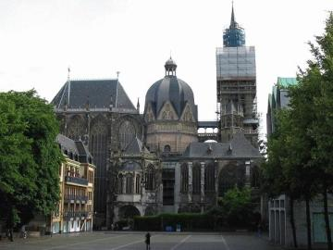
Palatine Chapel
Choir.
It is located on the east side of the chapel with measurements of length 25 meters, width 13 meters and 32 meters high. The external wall is broken by windows and thus called Glashaus (glass house).For the protection of the vault of the choir, iron rods were built in at the time of construction, to counter the lateral force in the narrow stone supports and to allow as much space as possible between them for window space.
West works.
It is a two-story building located at west end of the cathedral. The doors are attached with bronze leaves and each leaf divided into eight rectangles-symbolic to Sunday, the day of the resurrection of Jesus, and the boxes have strips with egg-shaped decorations-eggs were symbolic of life and fertility. The upper level was characterized by a fine brick western wall with the inside bulging to the outside and the outside to the inside thus to be seen as a convex-concave bulge (Ernst, 2002). The wall is also broken by a window. Upstairs part reserves space presumed for baptismal ceremonies. The lower room serves as Charlemagne's sepulcher after his death.
Throne of Charlemagne
Located on the western gallery on the lower floor opposite the choir.
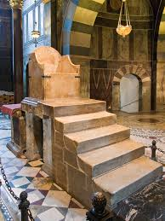
Barbarossa chandelier
It hung four meters above the ground from the vault of the dome and made up of eight faces.
Ambon of Henry 2(Heinrichskanzel)

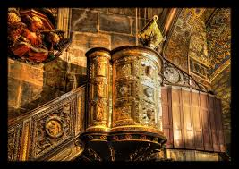

This is an erected pulpit which was magnificently made up of the oak base, decorated with filigree and precious stones, copper reliefs as well as six ivory panels toppled with wooden stairs.
In conclusion, the works of the cathedral had impacted significantly on other architectural works that include that of Essen Minster, the Abbey Church of Ottmarshein and the Old Tower in Mettlach. This influence was expressed vividly when the cathedral was nominated as a Historical landmark of German Civil Engineering back in 2007. The Catholic Church derives its historical and probably religious history to the existence and later death of the Holy Roman Emperor Charlemagne on 28th January 814 and his burial that followed in the Palatine chapel. Emperor Otto the third too was buried in the cathedral also and later his remains put in a gold and silver casket.

Bibliography
Roth, Hans Jürgen (2011). Ein Abbild des Himmels: Der Aachener Dom – Liturgie, Bibel, Kunst [ An Image of Heaven: The Aachen Cathedral – Liturgy, Bible, Art ] (in German). Aachen, Germany: Thouet.
Künzl, Ernst (2002). "Die Antike Bärin im Dom zu Aachen" [The Ancient Bear in the Aachen Cathedral].
Lepie, Hert & Minkenberg, Georg (2010) [1986]. The Cathedral Treasury of Aachen . Translated by Hargarter, Manjula Dias. Regensburg, Germany: Schnell & Steiner.
ISBN 3-7954-2321-X . LCCN 2010451623 .

